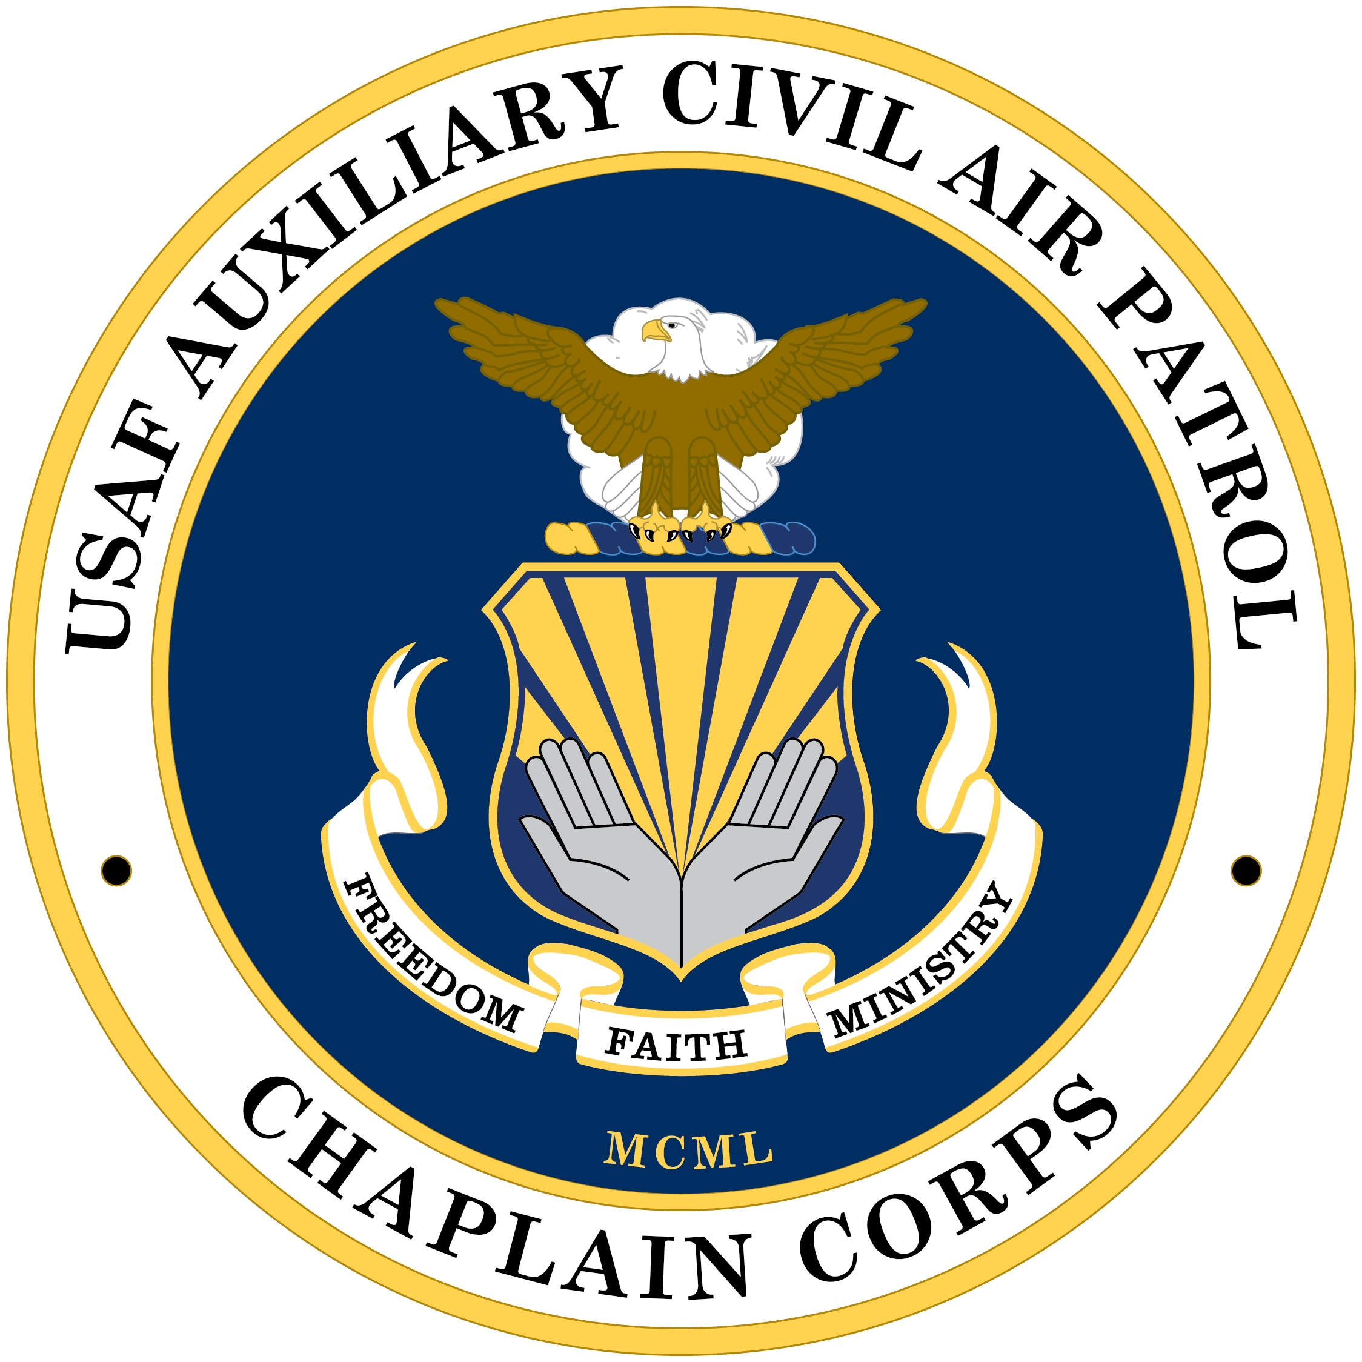 | The Receiver
January 2023 But be doers of the word, and not hearers only…. James 1:22 Vol 6 No 1
Announcements:  - Remember to record your activities in eServices. Keep it current.  - Keep your endorser apprised of them, as well.  - Plan ahead. Identify squadron, wing and national activities you are going to participate in. The National conference is in August in Bellingham, WA. Plan now to attend if you can.  - Identify the chaplain conference(s) you will go to.  - When are your wing conferences and encampments?  - The Transmitter, the national chaplain newsletter, can be found on the NHQ chaplain page. The link can be found on the RMR chaplain website.  - Another chaplain is needed for URMR.  Calendar:  NORTH CENTRAL REGION Chaplain Conference  April 24-28, 2023. More to follow including the RMR joint conference.  It’s January and a time when people often make resolutions for the new year. This new year, I would urge you to consider the challenge of complacency. We often get in the situation where things are going well and we tend to lose sight of the train that may be coming down life’s track. I know that I have been run over by that train and suspect you have had similar experiences. Complacency can affect our personal, work and CAP endeavors. So how do we protect ourselves from complacency? I offer several suggestions.  First: Vaccinate yourself by daily prayer and reflection about your status before God and your current situation. Be in harmony with your faith tradition and fellow beings. Honestly review how |  | things are going in work, family and CAP. What can you do better? I have found that in my daily prayers I reflect on the things for which I am grateful. By doing that, I become aware of the all that is good in my life and where my shortcomings are. Refrain from back patting and the “all is well” trap. That trap consists of looking at one’s current status as being satisfactory with no improvement or evaluation needed. When we fall into that trap, we cease to be aware of the train headed down the track in time to get out of the way. Getting out of the way means we reevaluate our actions and our beliefs of reality.  Second: Review your vulnerabilities regularly. What is your reality of risk? Risk analysis consists of looking at one’s responsibilities and evaluating the progress in accomplishing them. Awareness of the traps of procrastinating accomplishment is vital. Failing at expectations and promises is another weakness that invites the train to run over you. Pay attention to your actions. Be careful of that to which you commit. Don’t over commit what you can realistically accomplish. Don’t start projects you can’t finish. What message are you sending by what you do or don’t do.  Finally: Develop a moral palate. Let avoiding complacency become a lifelong CAP tenet that can carry over to the other areas of your life. Focus on the core values of Integrity, Service, Excellence and Respect. Let the principles of your faith tradition guide your everyday actions. Determine those things that feed complacency in your life and make a plan to eliminate them.  Thanks for all you do and for that which you are planning to do this coming year. Be an active chaplain/CDI. Let your faith tradition standards show through in all you do. Let people see God through your actions. Happy New Year!  This month’s author is Ch Jeff Johnson. jjohnson@hc.cap.gov

