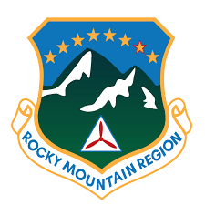
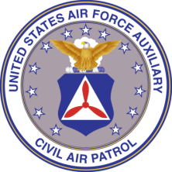
ROCKY MOUNTAIN REGION
STAFF VACANCY APPLICATION FORM

RANK FIRST M. LAST

CAPID:

Unit of Assignment:

Wing:

Region:

Current Duty assignment (Primary only):

Position applying for: (May select up to three, please list in priority order)

CAP Accomplishments: (List all experience, accomplishments or training that you feel qualifies you for the position. Do not forget to include a summary of your command/staff experience at the Wing, Region, or National level. NO MORE THAN TWO additional sheets may be attached if more room is needed.)

Other Accomplishments & Education: (You may list any other experience, accomplishments, or training you choose.)

RMR USE ONLY NOTES:
Date Received:
MEMBER SIGNATURE AND DATE:

